Jira Integration:
- Create REST Bi - Directional integration with JIRA by using Rest API with incident management in serviceNow and Issue in Jira.
- Outbound
  - Create a Basic Auth Configuration with Jira Credentials and Api Token
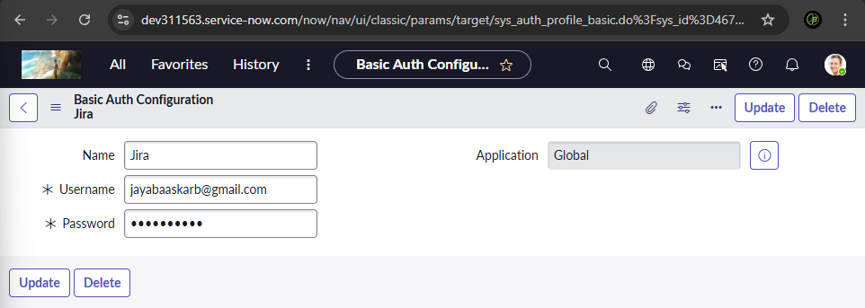
  - All > Integration Hub Credentials > Create New > Basic Auth Config.
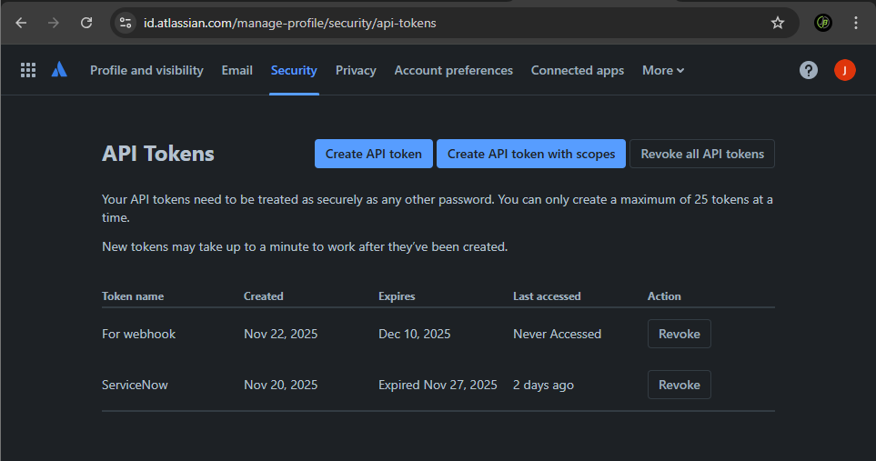
  - Api Token in Jira Nav: Account Settings > Security > Create or Manage Api tokens.
  - In Servicenow Go to All > Rest Message > Create New
  - Fill in Name and End point as Target Instance url of Jira, i.e, https://jayabaaskarb.atlassian.net/
  - Select Authentication Type as Required,(Basic Here)
  - Choose the Basic Auth Profile created Before.
  - Save and Submit

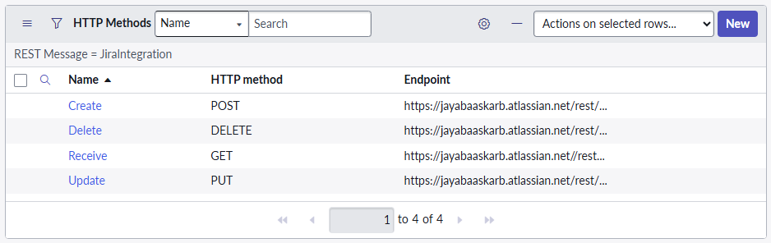
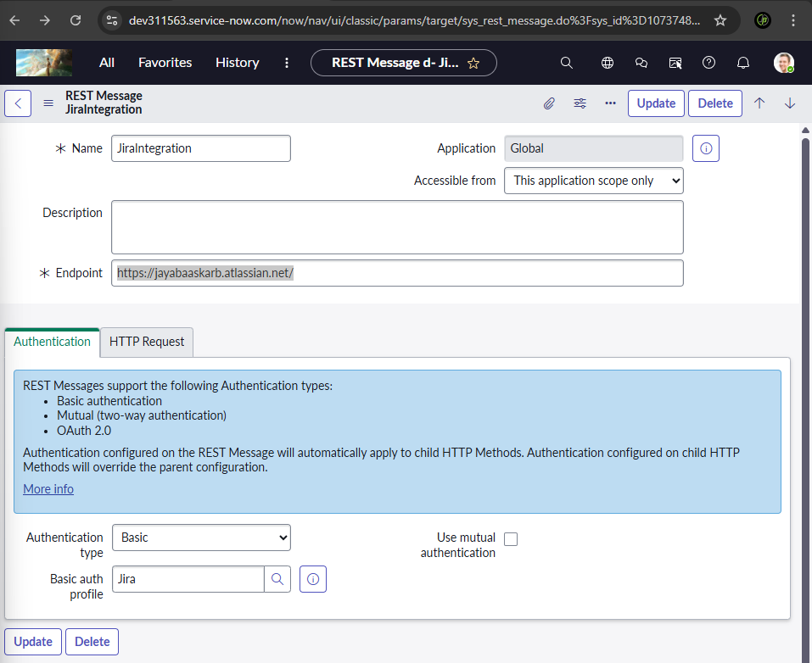
  - Create HTtp Methods for the Rest message with correct http method and endpoint and content using jira documentation

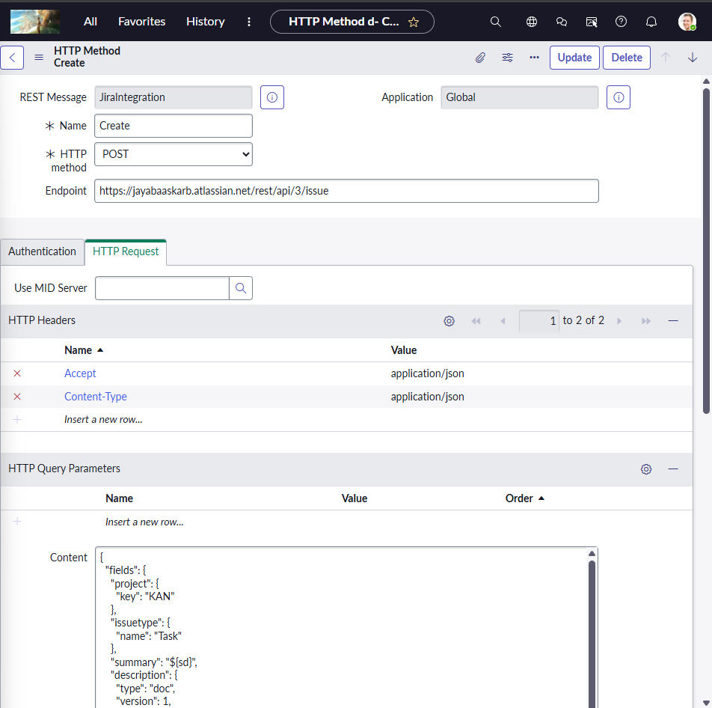
  - Post method -> Create with proper headers and required Content
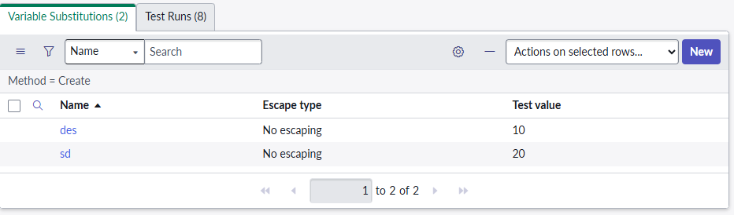
  - Test the content by giving Test Values

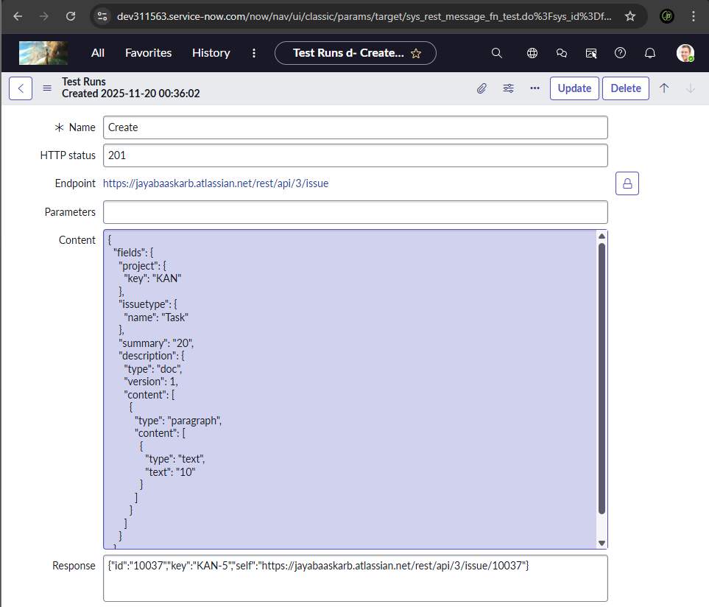
  - Http status 201 Indicates Proper Cnnection to Jira
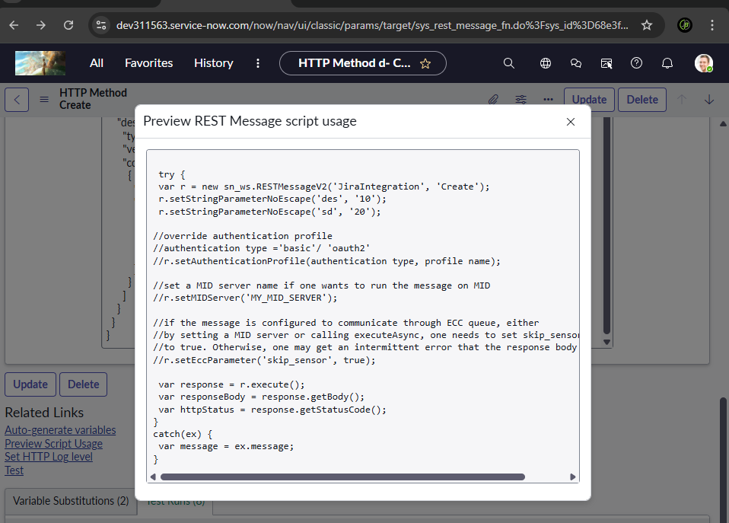
  - Preview Script Usage
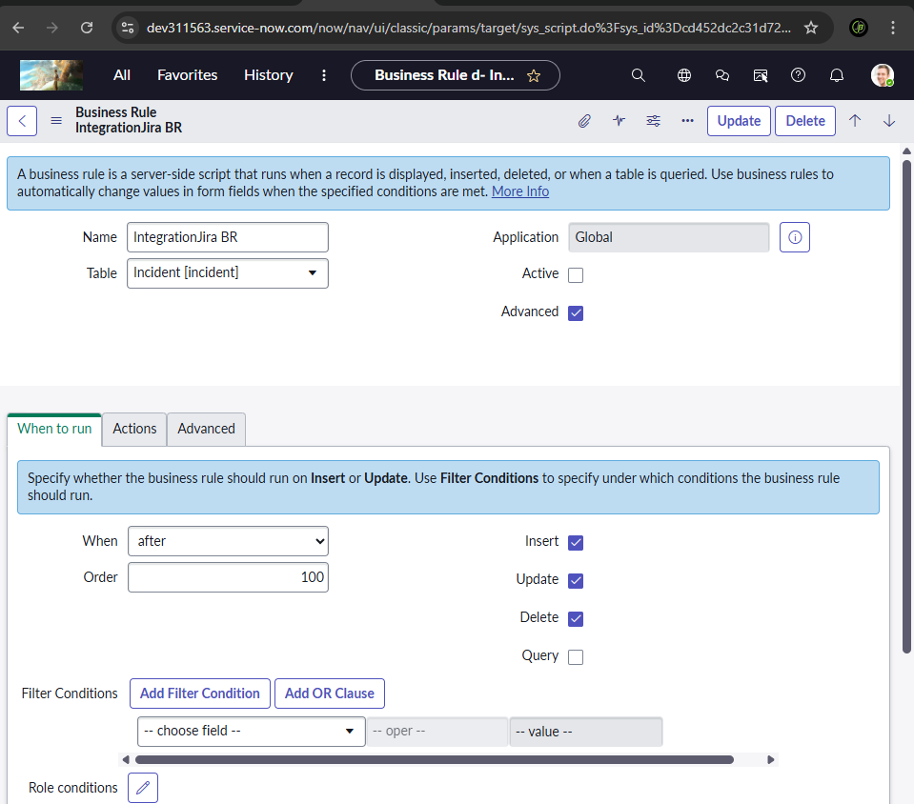
  - Copy the Script to Create a Business rule that runs After – Insert,Update,Delete in incident table
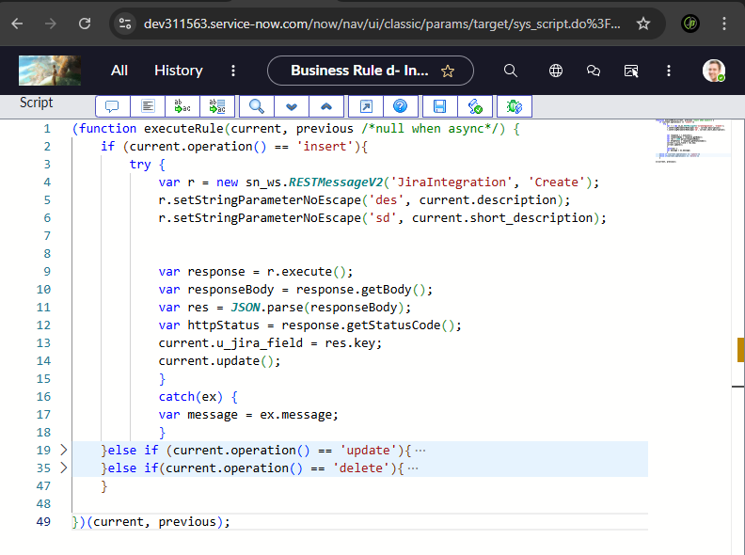
  - Paste the Copied Preview script and Point Variables to the Incident table Fields.(Create a custom field to populate Jira issue id for future use).
  - Repeat this process for Update and Delete.
  - Note that the endpoint suffix may vary for each http methodrefer Jira documentation
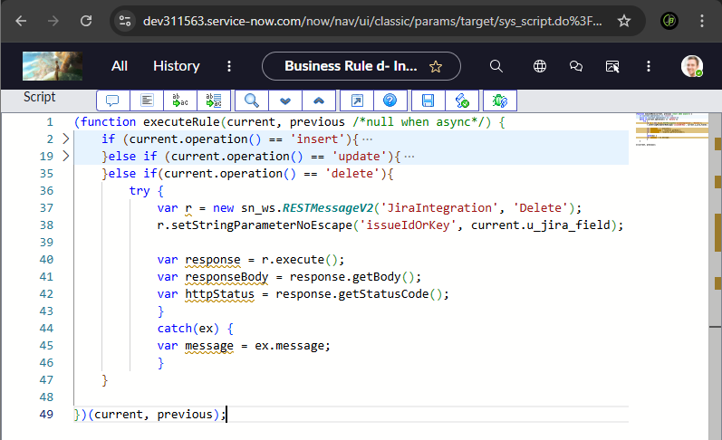
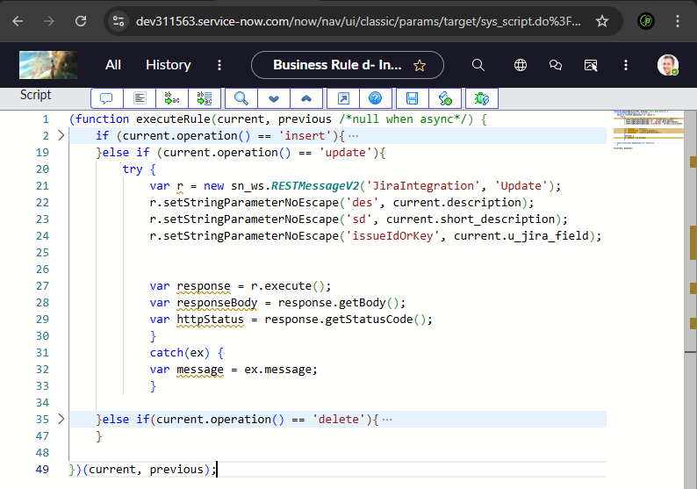
https://developer.atlassian.com/cloud/jira/platform/rest/v3/intro/#authentication

- Inbound – From Jira to ServiceNow
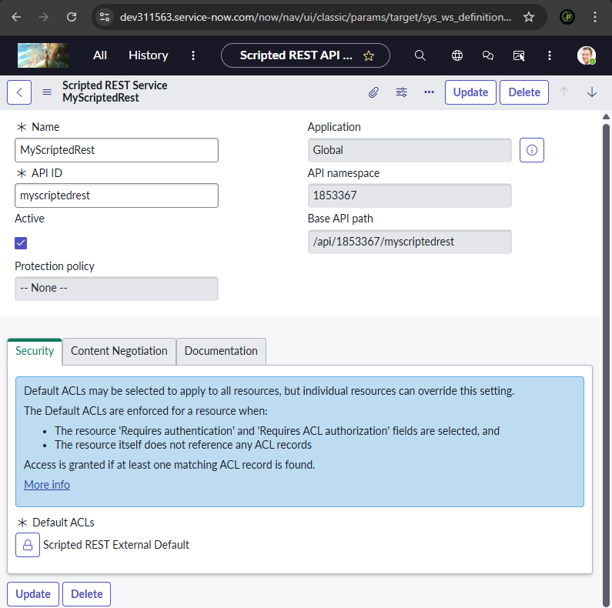
  - Go to Scripted Rest APIs in ServiceNow > Create New
  - Create new Resources
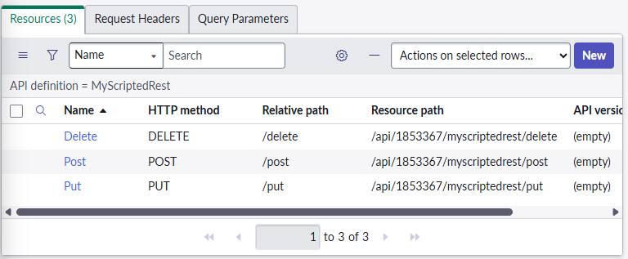

- Select Appropriate http method and add relative path
- Disable Requires Authetication in Security

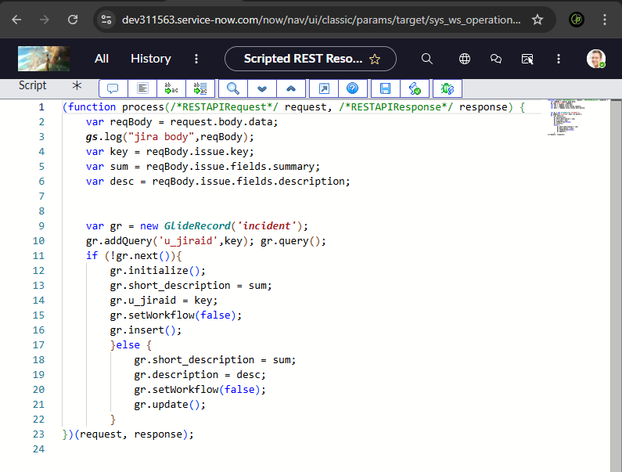
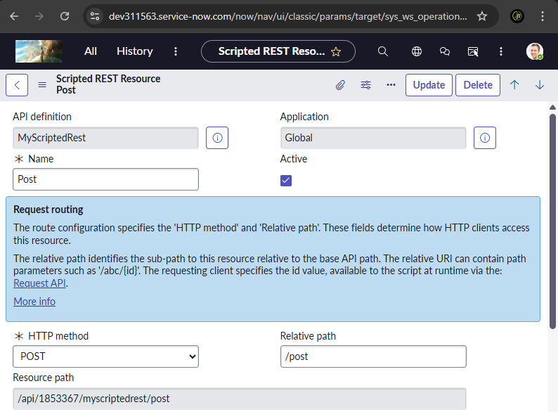
- Write the appropriate background script using rest commands and pull jira issue data to fill in Incident.
- Go to Jira webhooks for integration
- Jira admin Settings > System > Advanced > Webhooks > create new
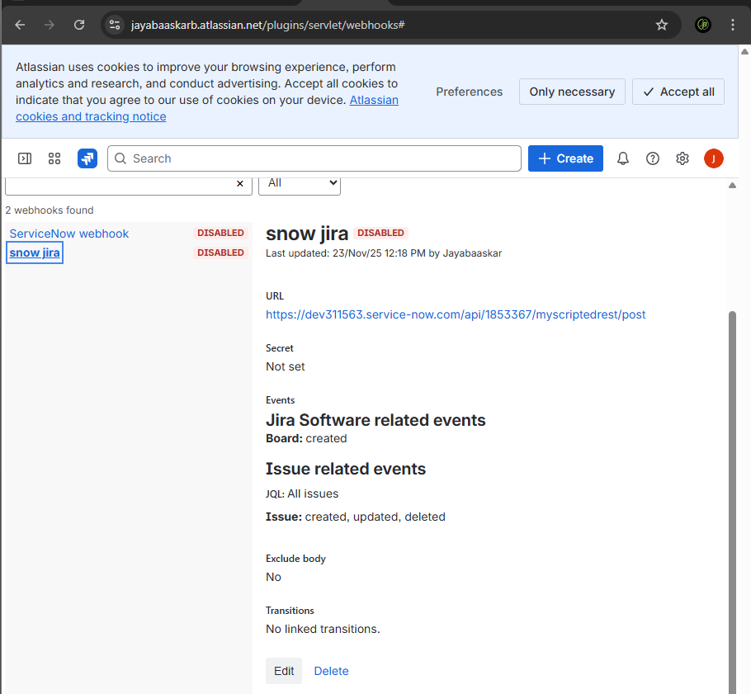
- Give Resource path as Suffix with the servicenow instance url serving as endpoint
- https://dev311563.service-now.com/api/1853367/myscriptedrest/post
- Whenever an incident is created,updated,deleted in servicenow same Operation will happen in the Jira issue table bidirectionally

